**Alan Himes**

**Week 12_13: Part 1: Viewing ERD’s in SQLDEV thru Data Modeler tool.**

1. **Open SQL developer and get connected to the server.**
2. **Click on VIEW at the Menu Bar and choose Data Modeler🡪 Browser**

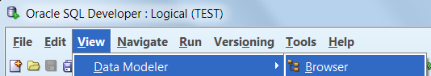

1. **Look on the LEFT towards the bottom for the Data Modeler Browser Window:**

**Right mouse on Relational Model You should see a new Relational Test window**

**Choose New Relational Model.**

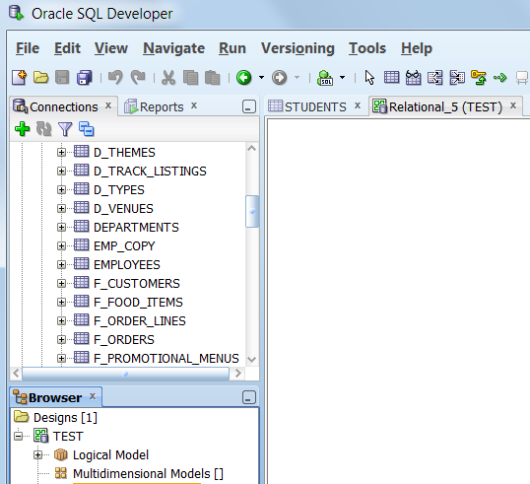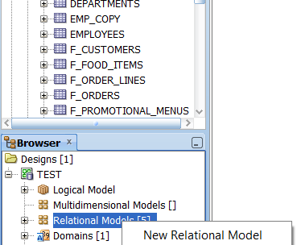

1. **Bring Tables into the RELATIONAL WINDOW:**

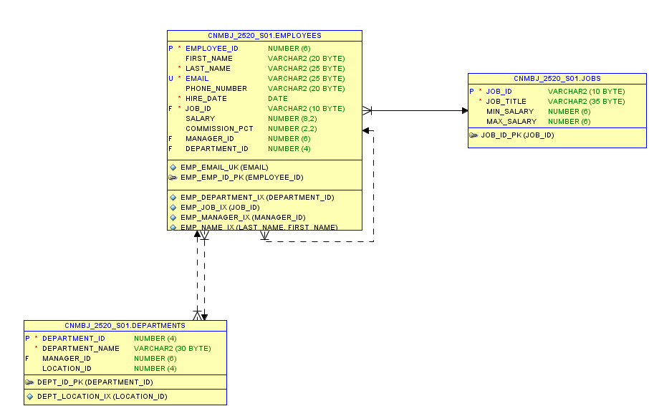**Click on EMPLOYEES TAB & drop it into the Relational Window:**

**Do the same for JOBS DEPTS tabs You should see the ERD diagram, you can move the entities around so the lines don’t cross ALL over.**

**To get the Logical Model like the ERD’s from 1513, Click on the blue arrow icons in the data modeler**

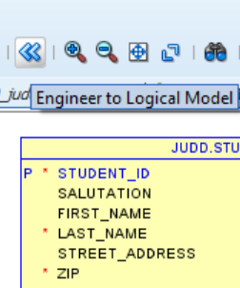

**This window opens, Then click on ENGINEER Button**

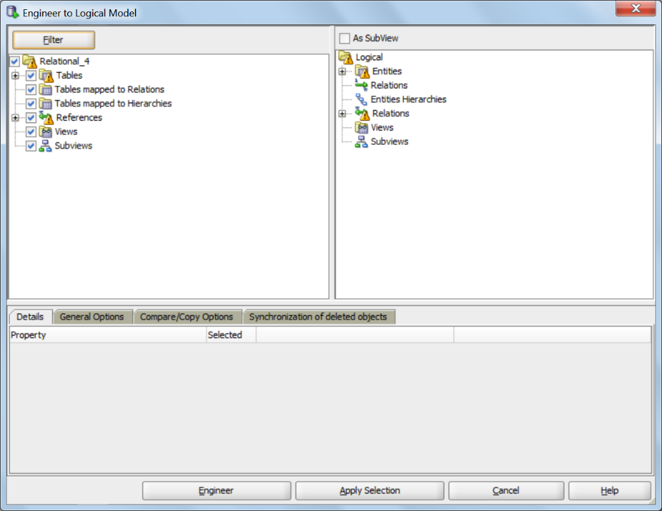

**Then you will see the BLUE ERD diagram. Turn in both diagrams. For this assignment.**

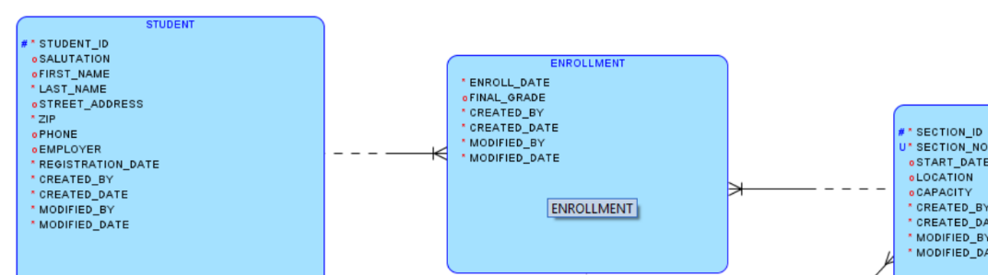

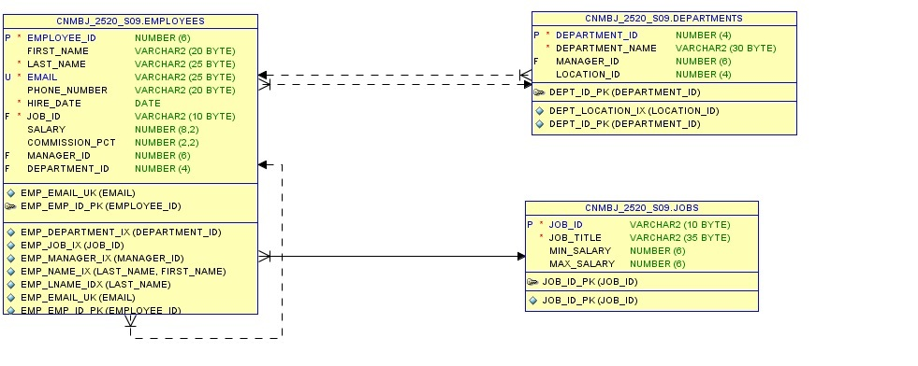

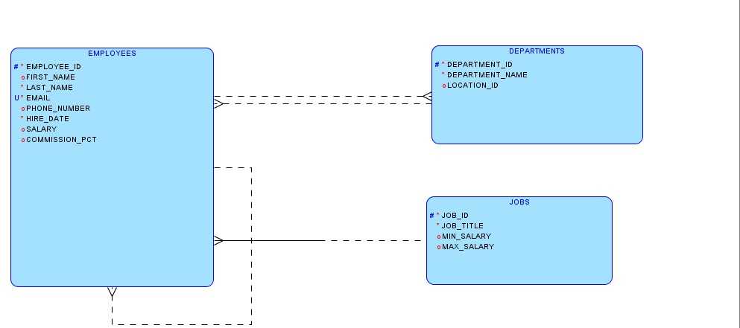

**Part 2: Importing SPREADSHEETs (csv) into SQL Dev. &**

**Relational View (Our table Instance Charts) from the Data Modeler in SQL Dev.**

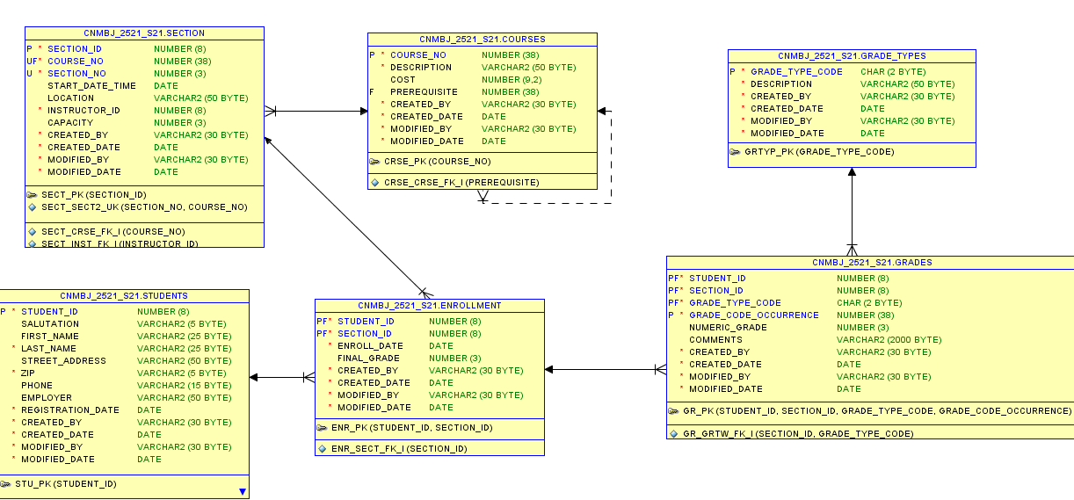

**Logical View (ERD-our diagrams) from the Data Modeler in SQL Dev.(using << blue arrow icon)**

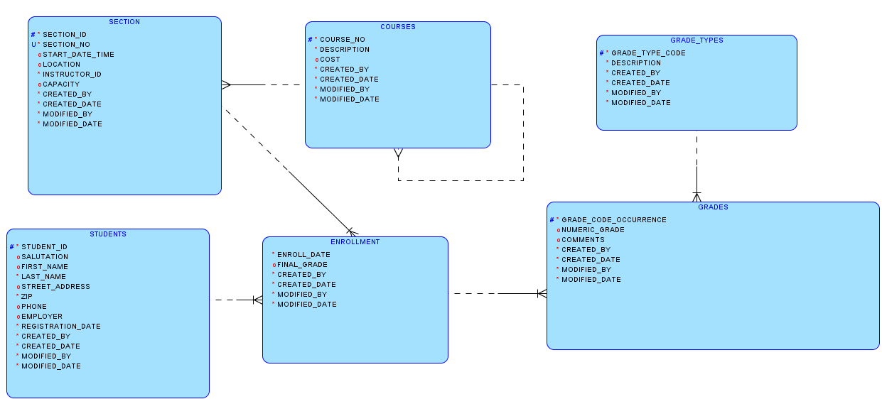

**Location of the SPREADSHEETS are attached to this assignment in blackboard or they are on the Q drive: Q:\Instructor\BJUDD\CIS2520_Intro_OracleSQL\Spreadsheets**

**Part 2 Importing Spreadsheets:**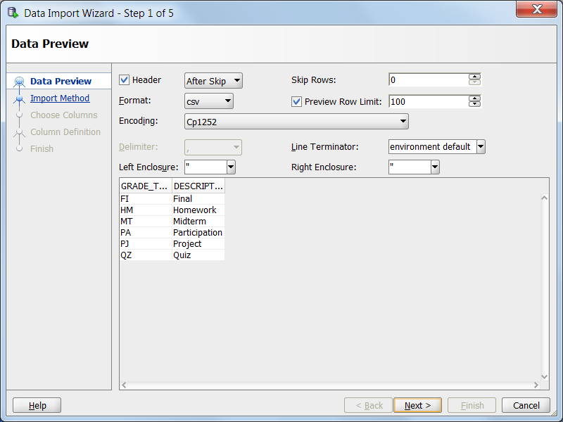

1. **Right mouse on the tables and choose IMPORT DATA -- choose the Q drive and the path above to find: Grade_types.csv**

**The wizard opens and asks you for a NAME for the TABLE: GRADE_TYPES.**

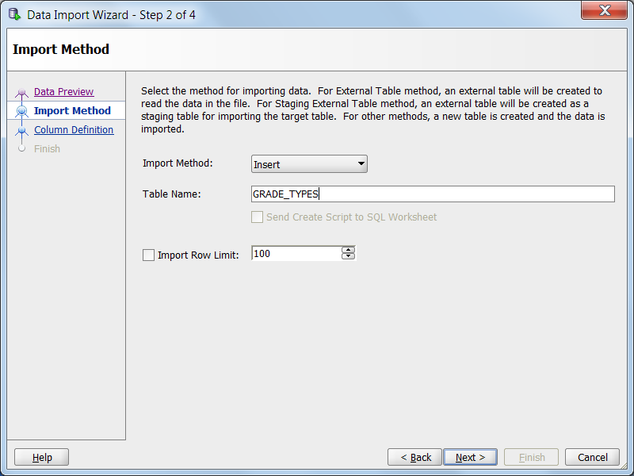

**ON STEP 4 Import wizard - STOP !! Look at the ERD so you will know the datatypes and lengths for each column. Click on each column and fix them up. The spreadsheet wants everything to be VARCHAR2. You need to fix all columns from ERD.**

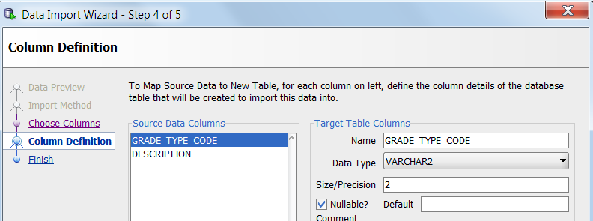

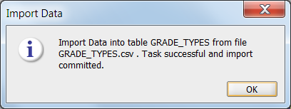**Click Next and you should get a message that the data was imported and committed.**

1. **We have to go to the Pencil and fix any constraints that we need to add, NOT NULL (check box) or Primary Keys or Foreign keys. If you look at the SQL code there aren’t any contraints at all, NOT GOOD ☹.**

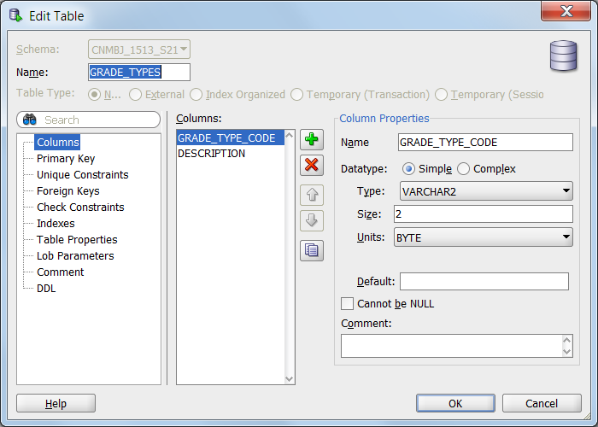

1. **Now go back and do the same for the Students, COURSES, Sections, GRADEs and Enrollment tables.**

**NOTE:**

**Always import the Parents 1st so when you go to the pencil to do Foreign keys you will have all the parent tables there. Set up all Pk’s in each Parent table 1st.**

**Turn in: 2 Data Modeler Charts**

1. **Screen print of your Relational Model (yellow)**
2. **Screen print Logical Model (blue ERD).**





